Chapter 15, Solution 55.

Take the Laplace transform of each term.

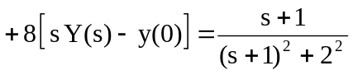

Setting the initial conditions to zero gives

 